Metropolitan State University

ICS 432: Distributed and Cloud Computing

Docker on a Local Linux VM

In this assignment, you will do the following:

1. Install Oracle Virtual Box.
2. Create a Linux VM using VirtualBox.
3. Install Docker on the Linux VM.
4. Run a flask app on Docker.

Note that steps 1 and 2 are based on Chapters 4 and 6 from Virtualization essentials book.

# Step 1: Install and setup Oracle VirtualBox

Oracle VirtualBox is a popular type-2 Hypervisor that can be downloaded from the following link: <https://www.virtualbox.org/>

Choose the Downloads link and select the correct choice for your host machine.

After downloading the VirtualBox executable, begin the installation by double clicking on the installed file.

Follow the default installation steps.

# Step 2: Create a Local Linux Virtual Machine

We will create a VM with the following configurations: 1 CPU, 1 GB of memory, and 20 GB of disk space. Then we will install the Ubuntu Linux OS on the VM.

1. Open VirtualBox and click on New from the top menu.

1. Enter details as shown in the following figure and click on continue:

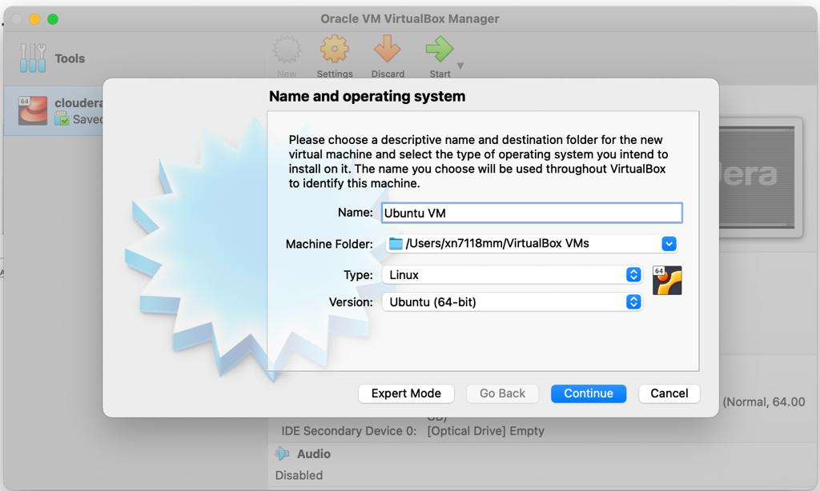

1. Keep the memory size to the default 1024MB then click on Continue.

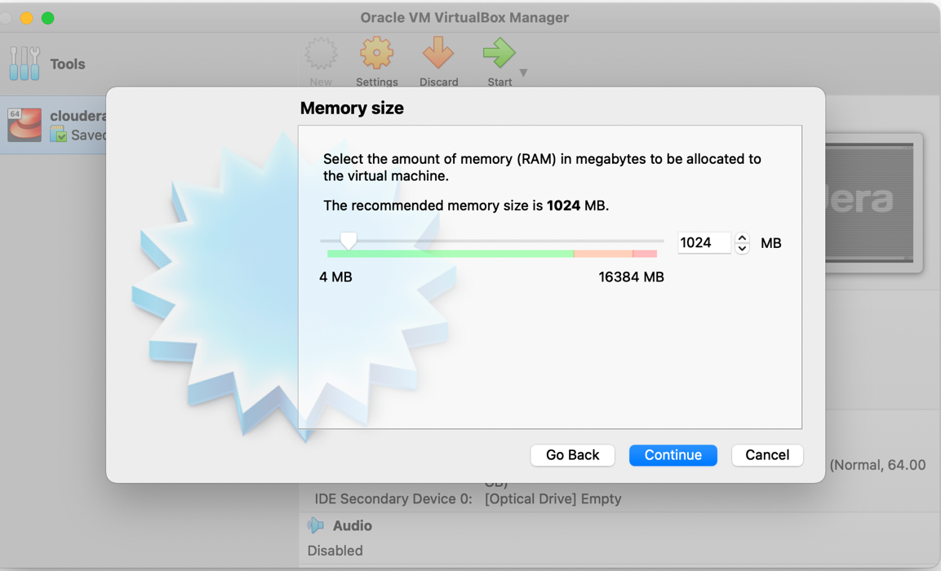

1. 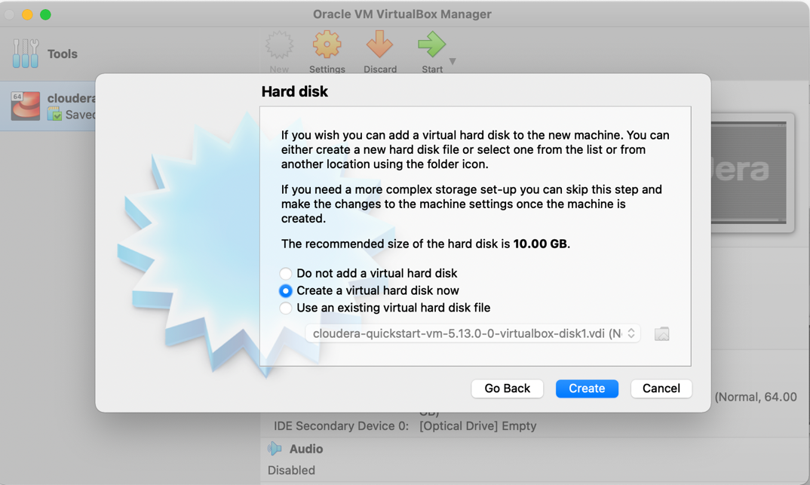Choose ‘Create a virtual hard disk now’ then click on create.
2. 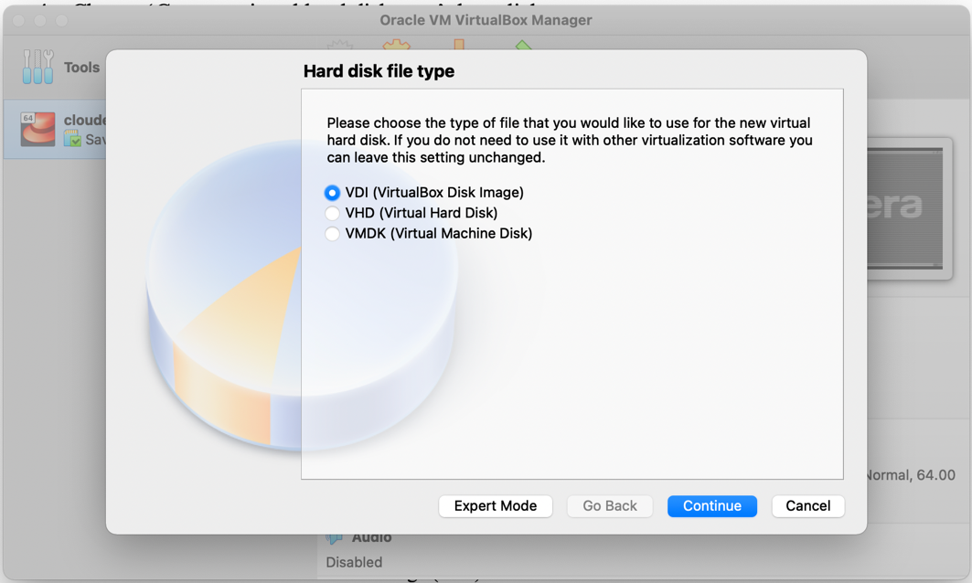The Hard Disk File Type screen gives you multiple options for the type of disk file type to create. keep the default with the VirtualBox Disk Image (VDI) and select Continue.
3. The next step show to choices for how storage allocation should be handled and what the differences are. Leave the default as Dynamically Allocated and click on Continue.

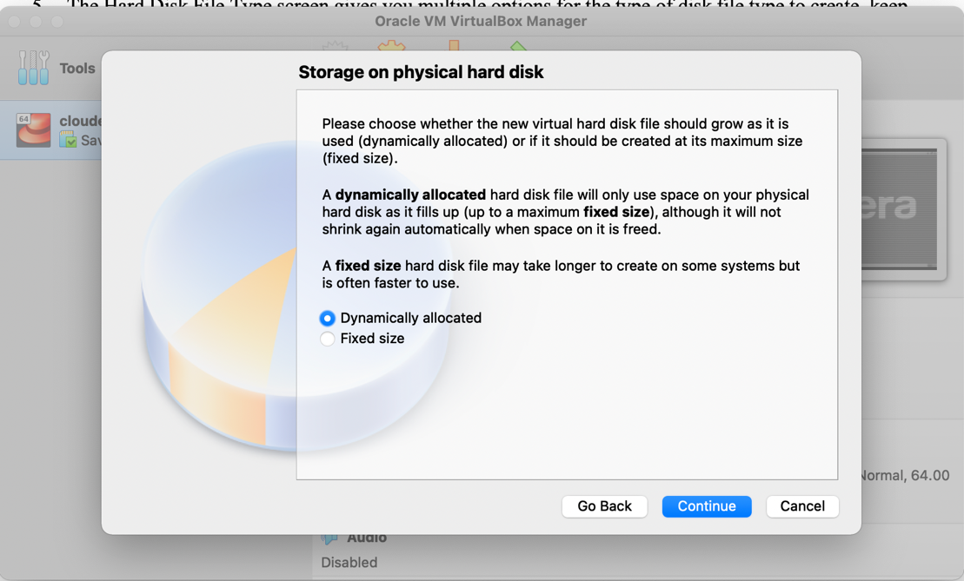

1. Leave the default file location but adjust the disk size to 20 GB. Choose Create to complete the virtual machine.

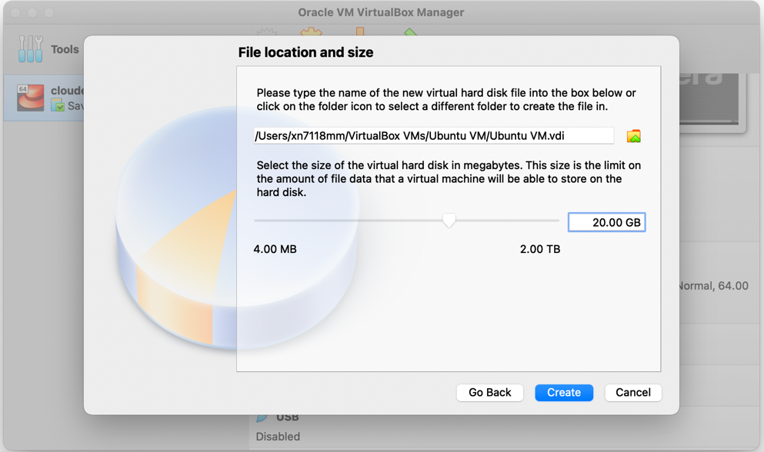

1. The virtual machine is created and you should see there is now an Ubuntu VM entry in the VM list in the left panel of VirtualBox. The main panel has the details of the virtual hardware that was just configured. It says that Ubuntu (64-bit) is the operating system, but that is only because we said we planned to install Ubuntu as part of the configuration. The operating system has not been loaded yet.

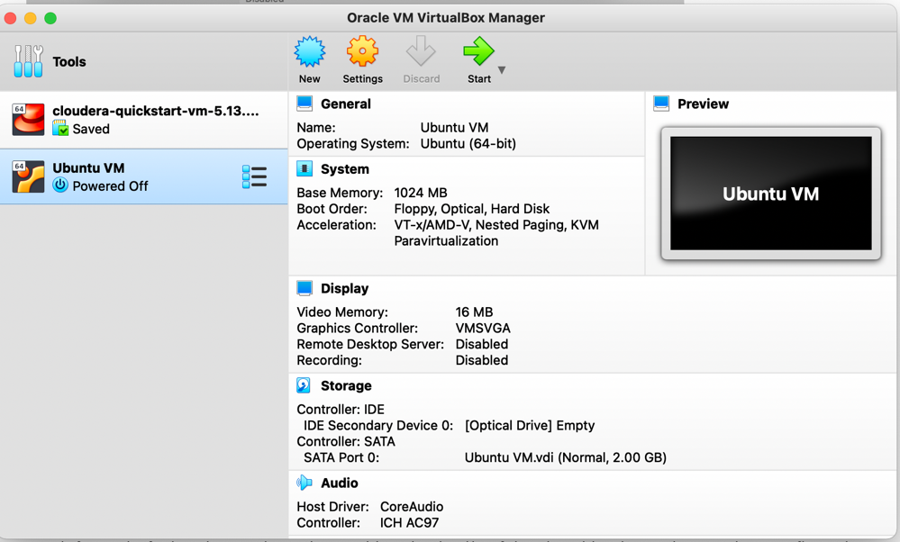

1. To install the OS, we need to virtually insert the installation disk into the VM’s CD/DVD drive by pointing the CD/DVD drive to the ISO image of the Ubuntu installation disk. We need to first download the Ubuntu installation disk.
2. Download Ubuntu by going to the following link: <http://www.ubuntu.com>. Click on Downloads and choose Ubuntu Desktop. Click on 20.04 LTS. Once the download is complete, you should have a file with extension .iso on your downloads folder.
3. 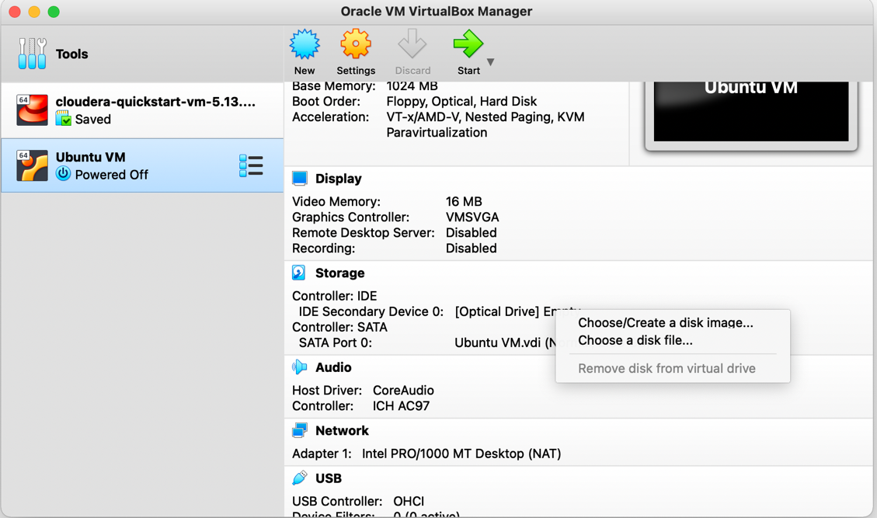Go to VitualBox, choose Ubuntu VM and click on in the Storage section of the VM’s settings, click on the [Optical Drive] Empty hyperlink and select Choose/Create disk Image.
4. Click on Add, a file browser window appears. Navigate and select the Ubuntu ISO disk image that you just downloaded.

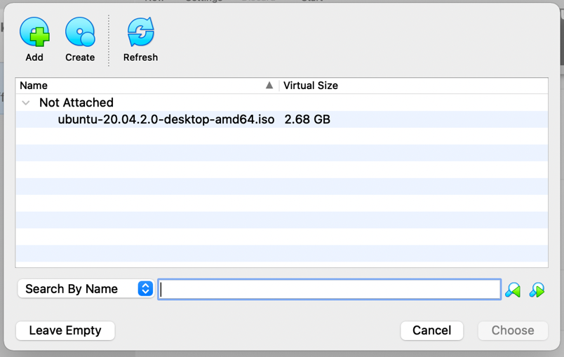

1. In the Storage section of the VM settings, the Ubuntu ISO file is now virtually inserted into the disk drive.

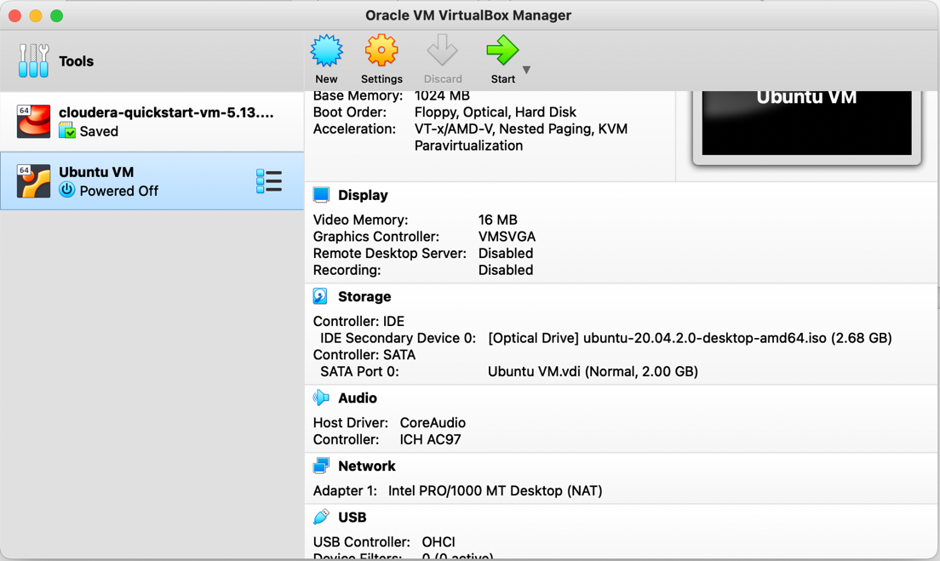

1. Click on Start. The machine will take sometime to start. To enlarge the screen size, go to view 🡪 Virtual Screen 1 🡪 Scale to 150%.
2. 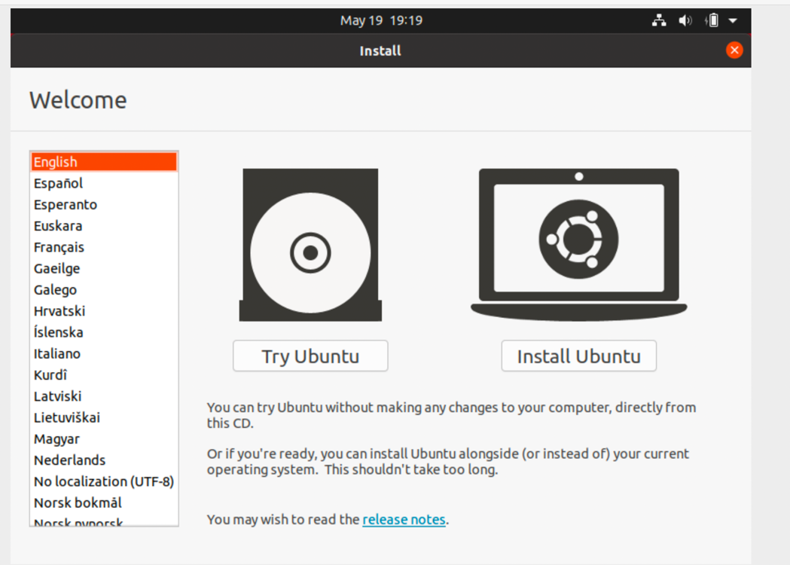Click on Install Ubuntu.
3. Click on Continue to accept the default installation steps.
4. 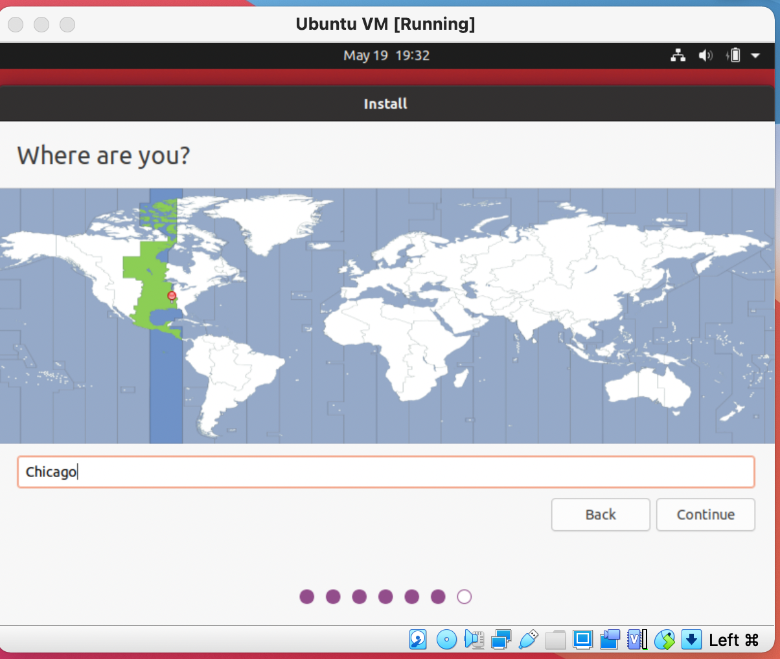For the location, choose Chicago then click on Continue.
5. Enter your information and choose ‘ics432fall2021’ as the password. Make sure to choose ‘Log in Automatically’.

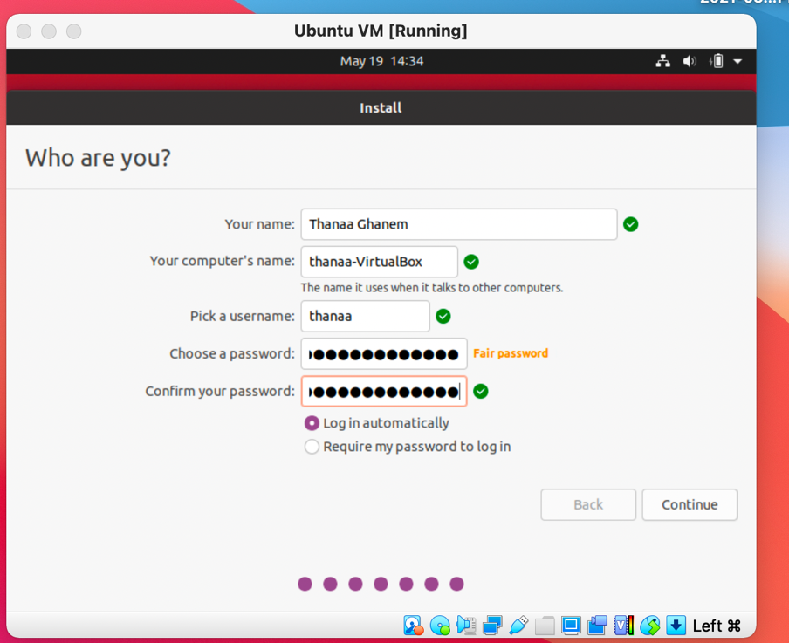

1. Once the machine starts, you should see screen similar to the following screen:

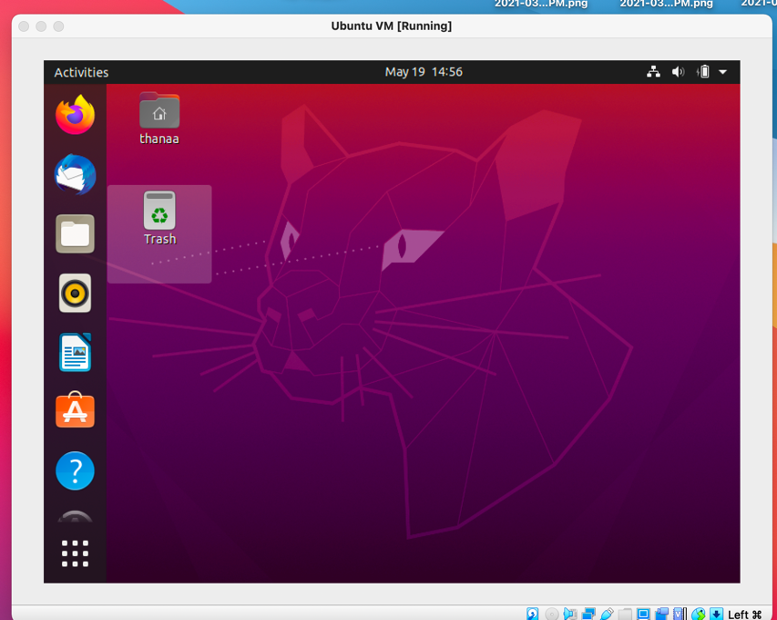

1. Double click on the folder with your name, then from the Home menu, choose Open in Terminal.

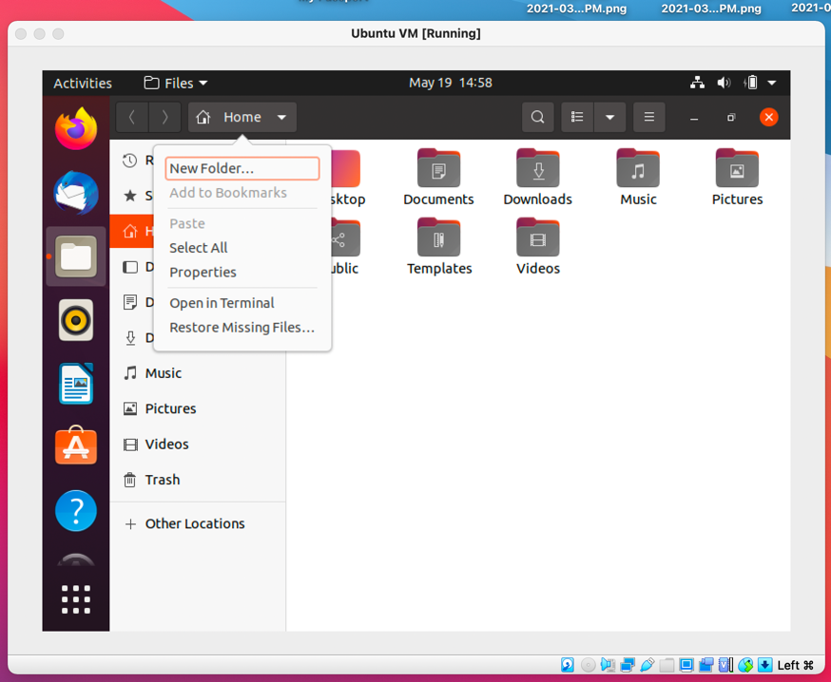

1. You should then have a terminal window and be ready to work on the Linux OS.

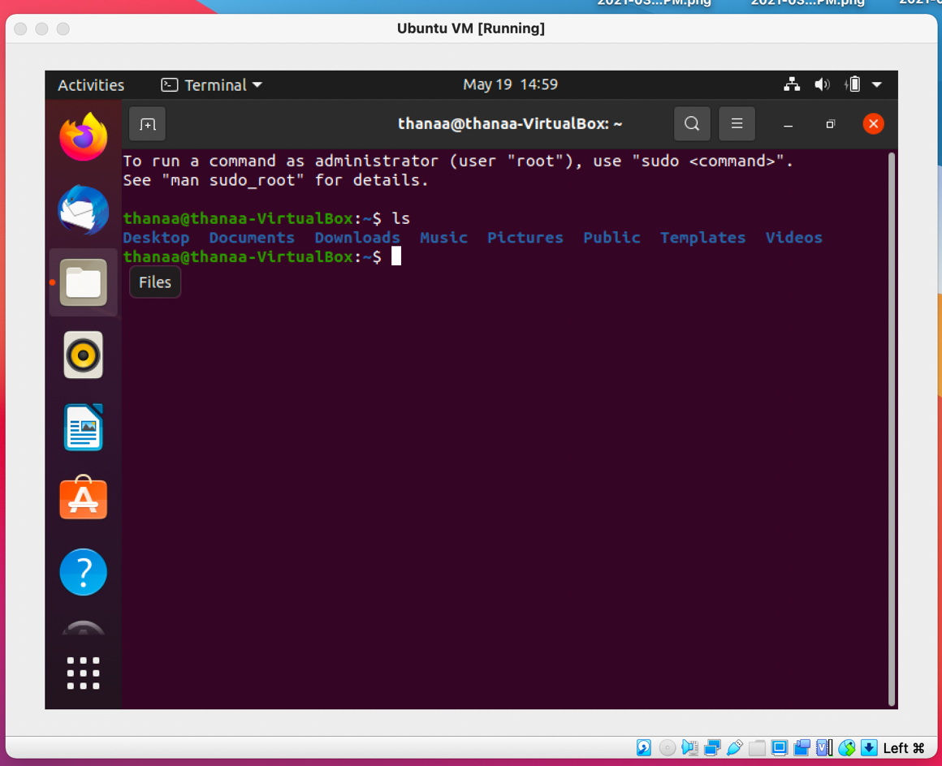

# Step 3: Install Docker

1. To know the version of your OS, type the following command in the VM’s command windows:

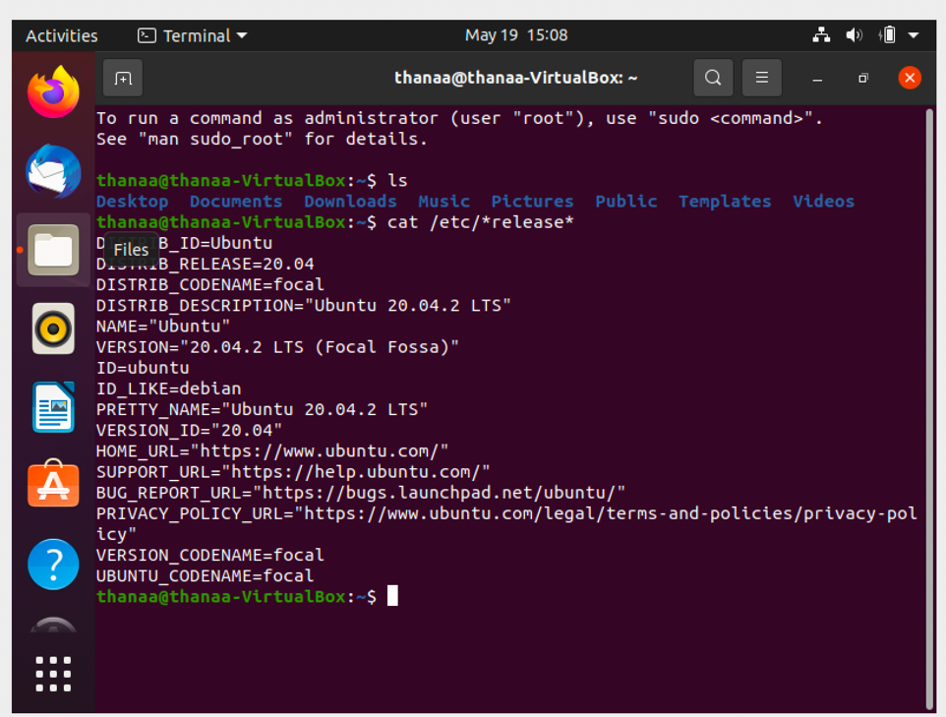cat /etc/*release*

1. From the Firefox browser inside the VM, Go to docs.docker.com and click on Download and Install.
2. Click on Docker for Linux.
3. Click on Ubuntu.
4. Uninstall old versions of docker by running the following command.

sudo apt-get remove docker docker-engine docker.io containerd runc

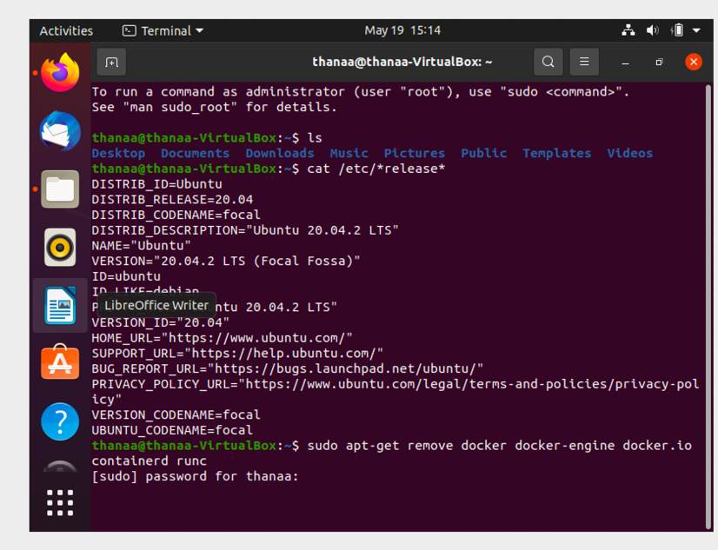

It’s OK if apt-get reports that none of these packages are installed.

1. In the docker web site, scroll down to the part with title ‘Install using the convenience script’.
2. Run the following command to download the script.

curl -fsSL https://get.docker.com -o get-docker.sh

Note: if you get an error saying that the command curl is not installed. Run the following command to install curl then go back and run the command to install the script.

sudo apt install curl

1. Run the following command to run the script.

sudo sh get-docker.sh

1. The installation takes few minutes to be completed.
2. Run the following command to know the version of the installed Docker engine.

sudo docker version

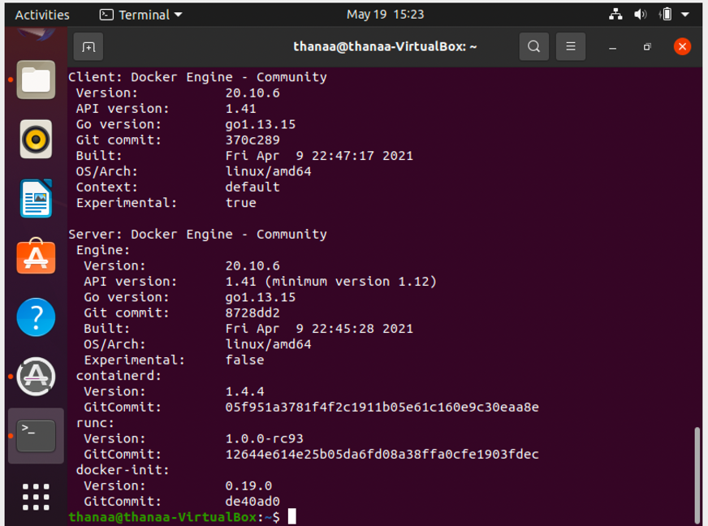

1. We will now run a simple container to make sure that everything is working as expected.
2. From Firefox inside the virtual machine, go to <http://hub,docker.com>. You can find the most popular docker engines on this site including MongDB, nginx, and many others.
3. From the top menu, click on Explore, then search for an image called whalesay which is a simple application that prints a whale say something.

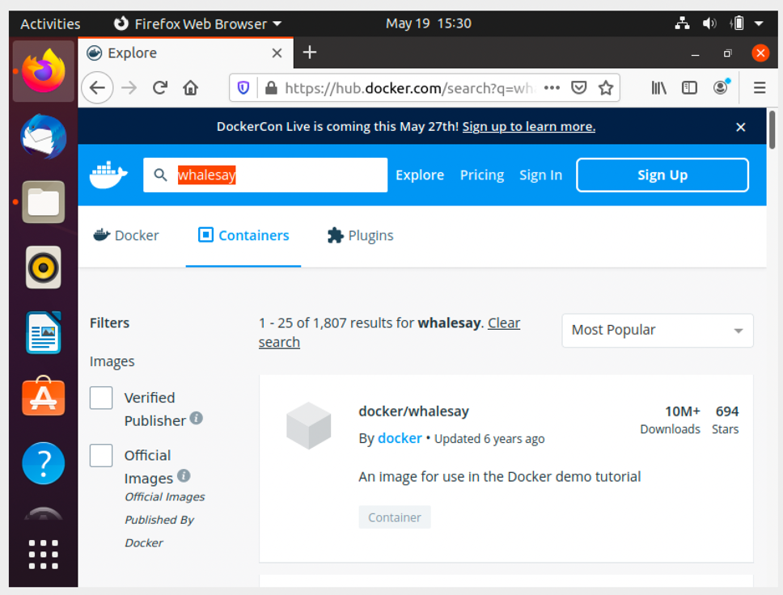

1. Click on the container and read about this application and how to run it.

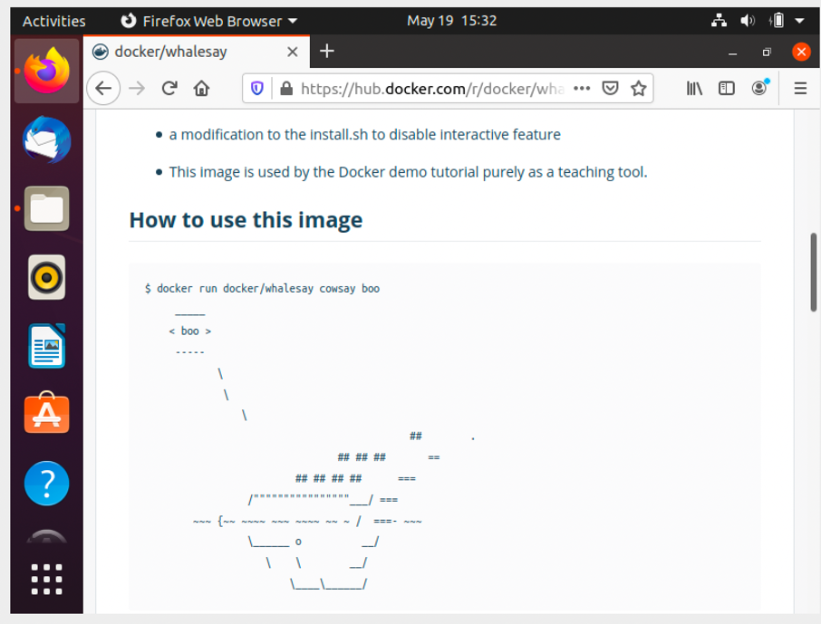

1. As explained in ‘How to use this image’, you can run the application using the following command and you can change the message to be printed by the program.

sudo docker run docker/whalesay cowsay <message>

for example,

sudo docker run docker/whalesay cowsay Hello-There,how-are-you!

1. Upon running this command, docker will pull the image from docker hub and runs it. Upon running, the application prints the message you entered.

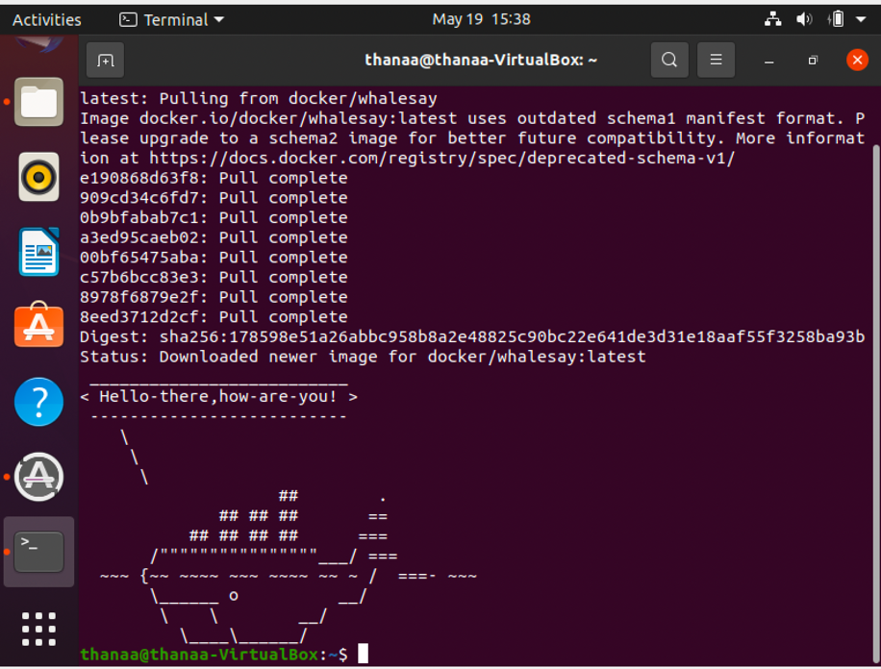

Answer the following questions?

What is the version of Docker Server Engine running on the Host? $docker version

How many containers are running on this host?

How many images are available on this host? $ docker images

Run a container using the redis image $docker run redis

Stop the container you just created $docker stop redis

Stop the container you just created ctrl+c or exit

How many containers are RUNNING on this host now? $

You are required to pull a docker image which will be used to run a container later. Pull the image nginx:1.14-alpine

Only pull the image, do not create a container.

Run a container with the nginx:1.14-alpine image and name it webapp

docker run nginx:1.14-alpine –name webapp

## Testing Basic Docker Commands

1. Go to <http://hub.docker.com> and click on Explore.
2. Look for centos image which is a Linux-based OS. Docker looks in the library that includes all the official images.

$docker run centos

1. Run the following command to run the bash command on the container:

$docker run -it centos bash

1. You should now see a command prompt from inside the container. Note that the command prompt root@xxx
2. Run the following command to check the version of the current OS:

cat /etc/*release*

1. Exit the container
2. Run the container again

docker run -d centos sleep 20

Run ps to see the details os the running container

docker ps

1. To see all the containers that you ran in the past including exited containers:

docker ps -a

1. To stop a container, use stop.

docker run -d centos sleep 2000

docker ps

docker stop <container_name>

1. To remove containers from your machine to reclaim disk space. You can provide just the first few letters from the container id.

docker rm <container_name>

1. To see the images you pulled

docker images

1. To remove an image

docker rmi <image_name>

Note that if you cannot delete an image while a container is running off this image.

1. You can pull an image without running a container.

docker pull hello-world

1. You can run a command on a container while it is running

docker exec <container_name> cat /cat/*release*

## Testing Advanced Docker Commands

1. To run a specific version of a software, go to <http://hub.docker.com>, search for the product and check the ‘Supported tags’ then append the tag to the container name.

By default, you run the Latest version of Ubuntu:

$docker run ubuntu cat /etc/*release*

To run a specific version:

$docker run ubuntu:17.10 cat /etc*release*

Note the version printed by both commands.

1. To run a container in the background:

$docker run -d ubuntu sleep 1500

To attach to a running container:

$docker ps 🡪 get container id

$docker attach <container_id>

1. Timer is a docker container that continuously printing the time on the screen.

$docker run timer 🡪 runs continuously, you have to open another command window to stop it.

$docker run -d timer 🡪 nothing is printed in the screen

$docker attach <container_id> 🡪 you can start seeing time being printed again.

# Step 4: Creating a docker image with a Flask application

In this part, we will create a docker image for a flask application called url-shortner. The application folder consists of the following:

* 1. templates (a folder of HTML templates)
  2. app.py
  3. requirements.txt
  4. app.yaml
  5. urls.json

We will first run the application step-by-step on a docker container then we will create an image for the application.

## Steps to run a flask application on a docker container

First, we will run the application step-by-step on a docker container by the doing the following:

1. Install all required dependencies.
2. Install and configure Web Server
3. Start web Server
4. Test.
5. Open a command window on the VM and create a folder called flask-app.

mkdir flask-app

change directory to flask-app

cd flask-app

1. Start an Ubuntu image with bash window (attach the command window to this container):

docker run -it ubuntu bash

1. Install python:

apt-get update

apt-get install python

Test the installation is successful by running the python command:

python

If python is successfully installed, you should see a message with the current Python version and then you see the Python’s prompt (>>). Type exit() to exit python.

1. Install flask:

apt-get install pip

pip install flask

1. Copy the source code of the application to docker container. Note that you need to first copy the source code from your local machine to the virtual machine then copy the source code to the container.
   1. Copy the source code from local machine to the VM:

There are different ways to do that but the easiest way is to do the following:

* Compress the application folder into a zip file.
* Send the zip file in an email attachment to your gmail account.
* Open your email from the browser on the VM and download the zip file. You should see the file saved under the downloads folder in the VM.

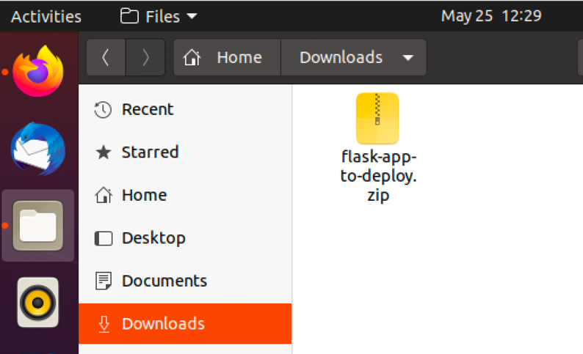

* Open a terminal window on the VM (other than the terminal that is connected to the container).
* Change directory to flask-app and copy the zip file from the Downloads folder using the following command

cp ../Download/flask-app-to-deploy.zip .

* Unzip the file using the following command:

unzip flask-app-to-deploy.zip

* 1. Copy the source code to the container in a folder called /opt
* From the container command window, type ls to see a list of the folders. You should find a folder called opt.
* Copy the files from inside the flask-app-to-deploy folder to the opt folder on the container. From the command window on VM, type docker ps to get the CONTAINER ID.
* Run the following command to copy all files (*):

docker cp ./flask-app-to-deply <CONTAINER_ID>:/opt

* Go back the container’s command window and make sure that the flask-app-to-deploy folder is copied to the /opt folder

1. Inside the container, change directory to be inside /opt/flas-app-to-deploy folder and then run the web server using the following commands:

FLASK_APP=app.py

flask run --host 0.0.0.0

1. Go the browser on the VM and access the container using the following URL:

<http://172.17.0.2:5000>

1. You should see the url-application running as follows

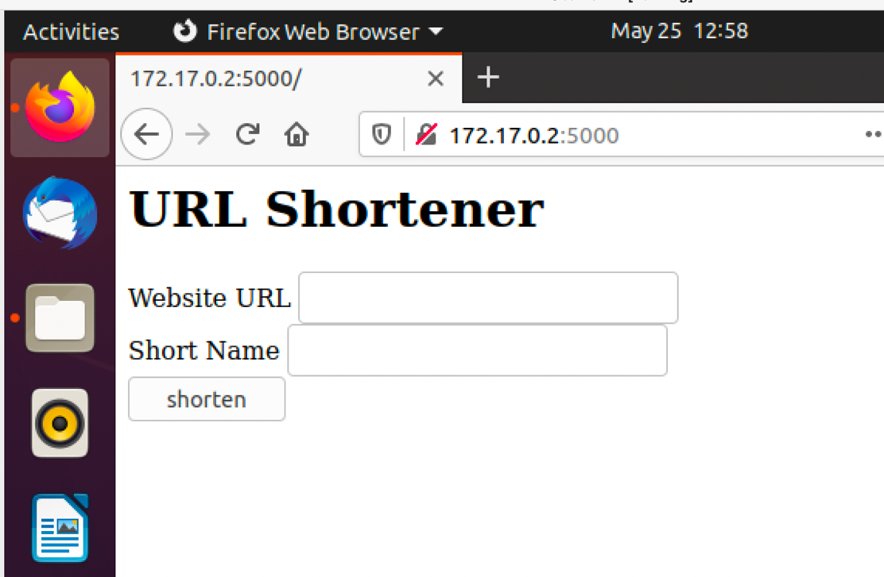

1. Use ctrl-c to stop the running web server.
2. Type history on the container’s command window to see a list of all the commands that were performed on the container. These commands (and the order in which they are executed) will be used to create the container image.

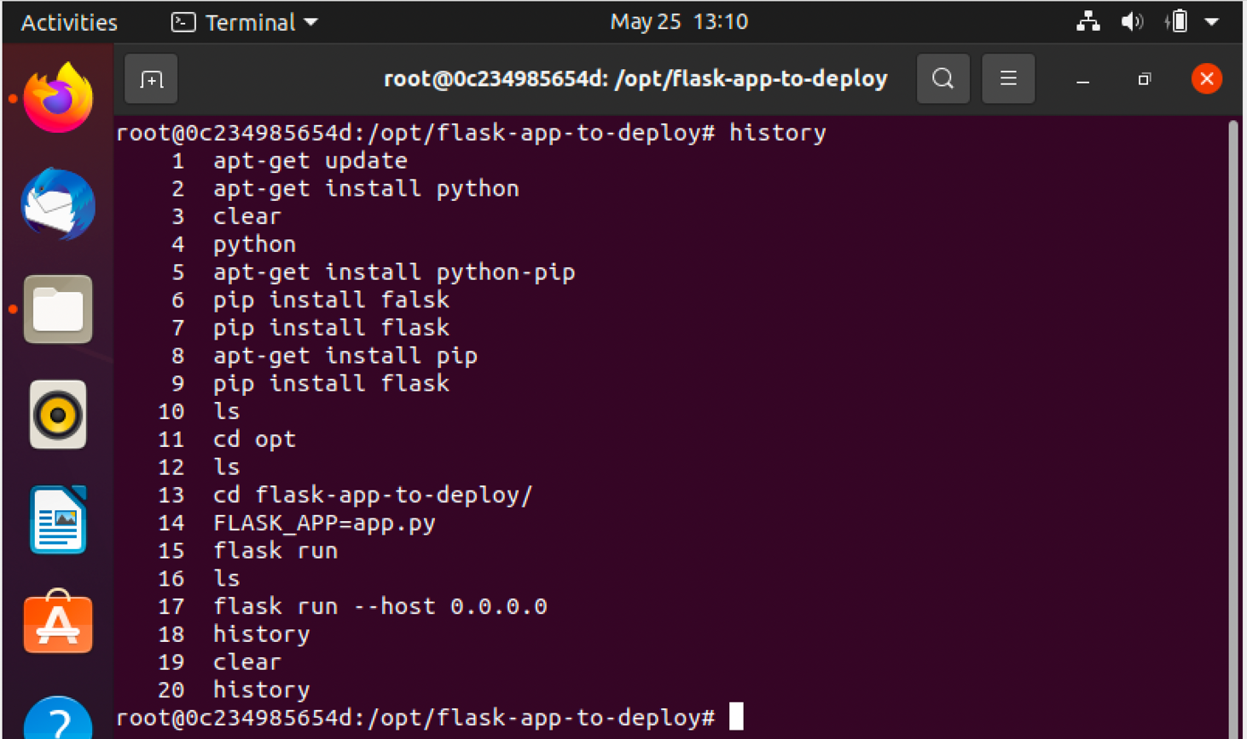

1. Note that all the command are documented except the step of copying the application from the local machine to the container. The summary of steps is as follows:

apt-get update

apt-get install python

apt-get install pip

pip install flask

**copy the folder flask-app-to-deploy to the /opt folder inside the container***

cd /opt/flask-app-to-deploy

FLASK_APP=app.py

flask run

1. Type exit to stop the container and type docker ps to make sure that the container is stopped.

## Creating a Docker image for the url-shortner application

1. From the command window on the VM, change directory to be inside flask-app directory

cd flask-app

1. Use the following command to create a text file called Dockerfile

cat > Dokerfile

Type ctrl-c to close the file. We will open the file using a text editor. Go to the desk top of the VM, double click on the folder with your name, then double click on flask-app folder, then double click on Dockerfile

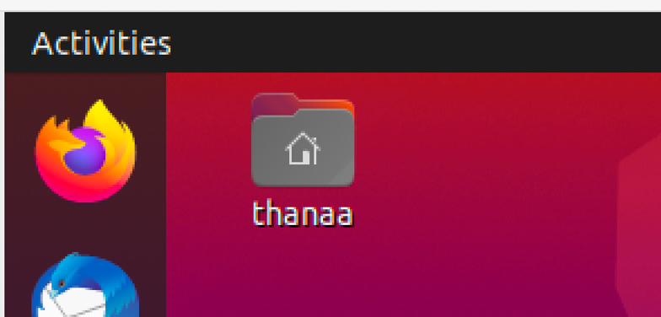

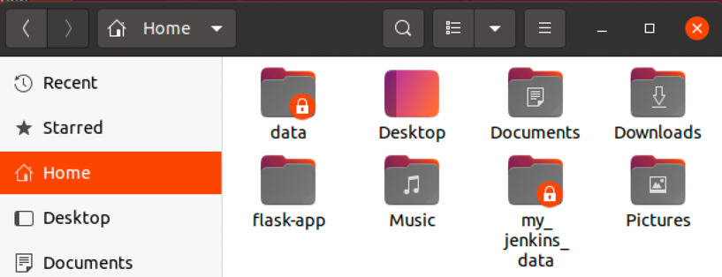

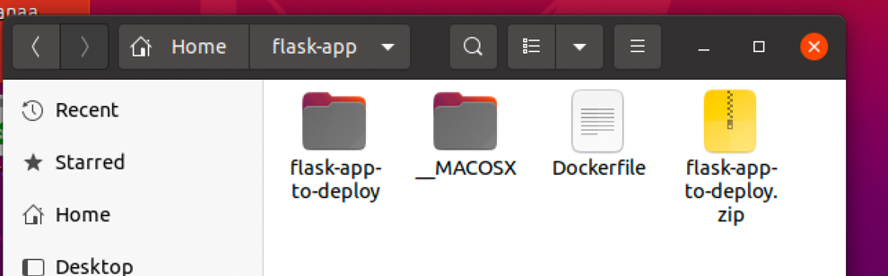

The file will open in text editor. Type the following inside the Docker file and then click Save.

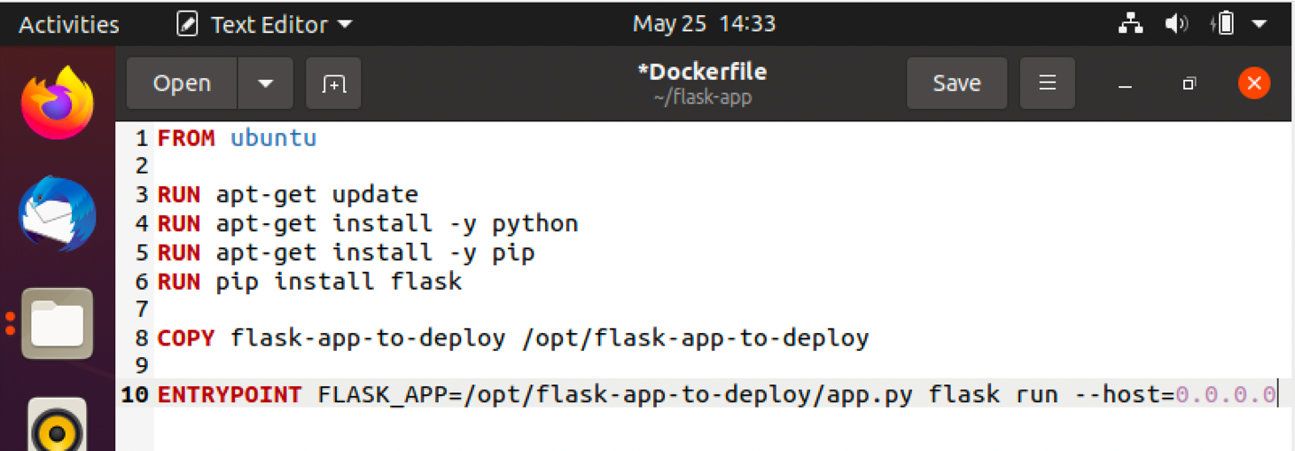

1. Go back to the command window and build the image

docker build .

While the image is being built, you can see the messages about the various steps being executed.

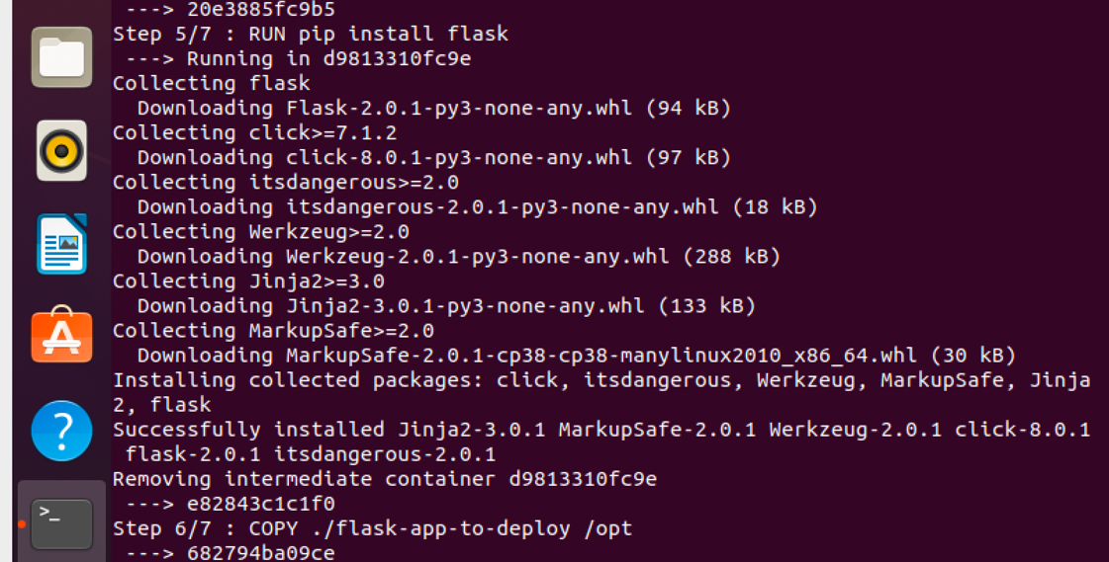

1. If you want give a name to the image, run the following command:

docker build . -t url-shortner-flask-app

Note that the image is not re-built so the process is very quick. Remember that all the layers are cached.

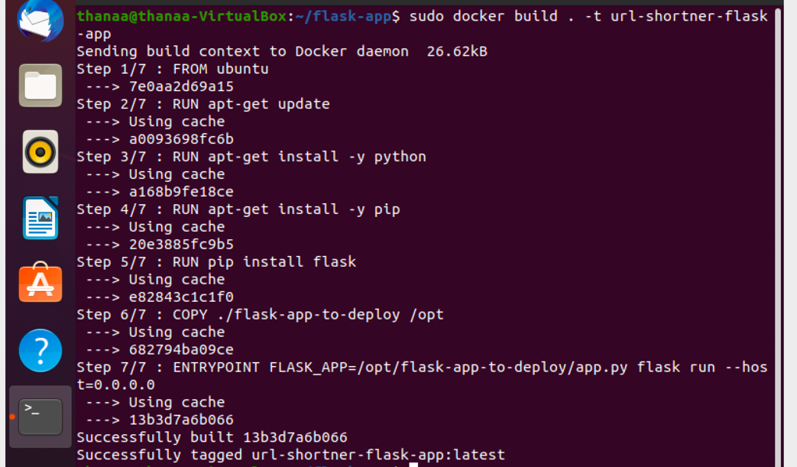

1. See the image using docker images
2. Run a container using the image

docker run url-shortner-flask-app

1. Open a browser window and check the application using the following URL: <http://172.17.0.2:5000>
2. To stop the container, you need to open a command window on the VM, run docker ps to get the CONTAINER ID then stop the container using

docker stop <CONTIANER ID>

## Push an image to docker hub

1. Create an account on Docker hub. Go to <http://hub.docker.com> and click on Sign up. Then follow the steps to create an account. Choose the Free option. When you receive the confirmation email, click on the link to verify your email address.
2. Create an image and tag it with your account name

docker build . -t thanaaghanem/url-shortner-flask-app

1. Login to docker hub:

docker login

Enter your user name and password. You should receive a message saying ‘Login Succeeded’.

1. Push the image to your docker repository:

docker push thanaaghanem/url-shortner-flask-app

1. Wait until the push command is completed and then go to your account on docker hub and go to the ‘Repositories’ tabl and make sure that the application is pushed. Note that the application is public because with a free account you can have only one private image.

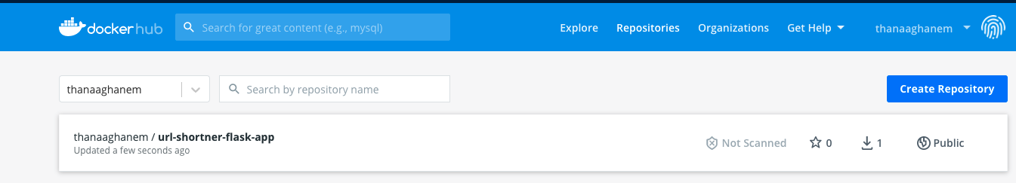

Given the following Docker file

$ cat Dockerfile

FROM python:3.6

RUN pip install flask

COPY . /opt/

EXPOSE 8080

WORKDIR /opt

ENTRYPOINT ["python", "app.py"]

1. Where the application code is copied inside the container? /opt
2. a container is created using the image built with this Dockerfile, what is the command used to RUN the application inside it. python app.py
3. What port is the web application run within the container? 8080
4. Build a docker image using the Dockerfile and name it webapp-color. No tag to be specified. docker build . -t webapp-color
5. Run an instance of the image webapp-color and publish port 8080 on the container to 8282 on the host. docker run -p 8282:8080 webapp-color
6. What is the base Operating System used by the python:3.6 image? If required, run an instance of the image to figure it out. docker run -it python:3.6 bash cat /etc/*release*

rhel/debian/ubuntu/centos

1. What is the approximate size of the webapp-color image? docker images
2. Build a new smaller docker image by modifying the same Dockerfile and name it webapp-color and tag it lite. Hint: Find a smaller base image for python:3.6. Make sure the final image is less than 150MB.

## Running your container on Google Cloud

Go to GCP console and make sure to connect to your course account.

Activate cloud shell.

Run docker version to make sure that docker is set up.

Run the following command to create a container that is running the url-shortener-application

docker run -p 5000:5000 thanaaghanem/url-shortner-flask-app

Your command window should look as follows which indicates that the container is running.

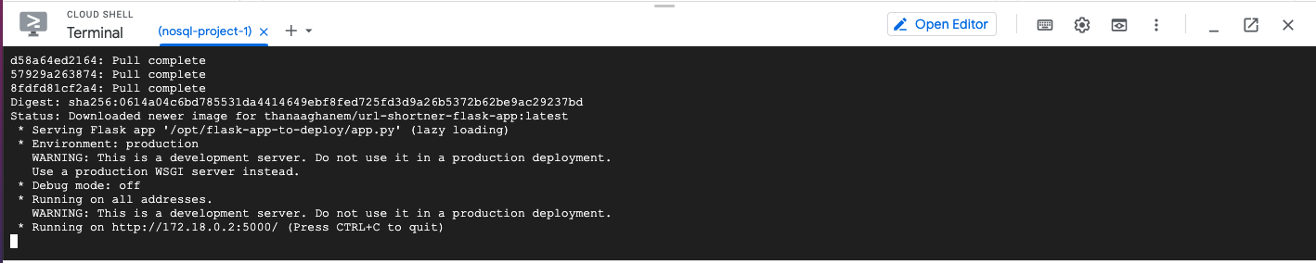

Click on the web preview icon

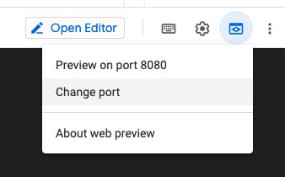

Click on Change port, enter 5000, and then click on Change and Preview.

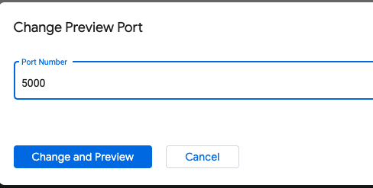

You should then see the url-shortner application running the browser. Notice the URL.

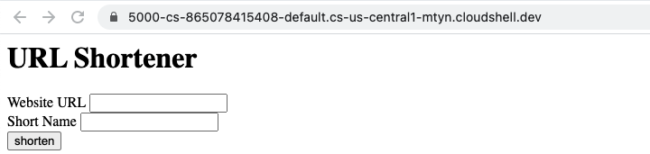

You can access the other methods of the application by appending the method name to the URL. For example

[https://5000-cs-865078415408-default.cs-us-central1-mtyn.cloudshell.dev**/api**](https://5000-cs-865078415408-default.cs-us-central1-mtyn.cloudshell.dev/api)

or

[https://5000-cs-865078415408-default.cs-us-central1-mtyn.cloudshell.dev**/parameters?name=john&age=50**](https://5000-cs-865078415408-default.cs-us-central1-mtyn.cloudshell.dev/parameters?name=john&age=50)

When you go back to the command window, you will not be able to interact with command line because the container is running. To stop the container, you need to open a new command window (using the plus sign at the top) and run the following commands:

docker ps 🡪 to get container id

docker stop <container id>

docker remove <container id>